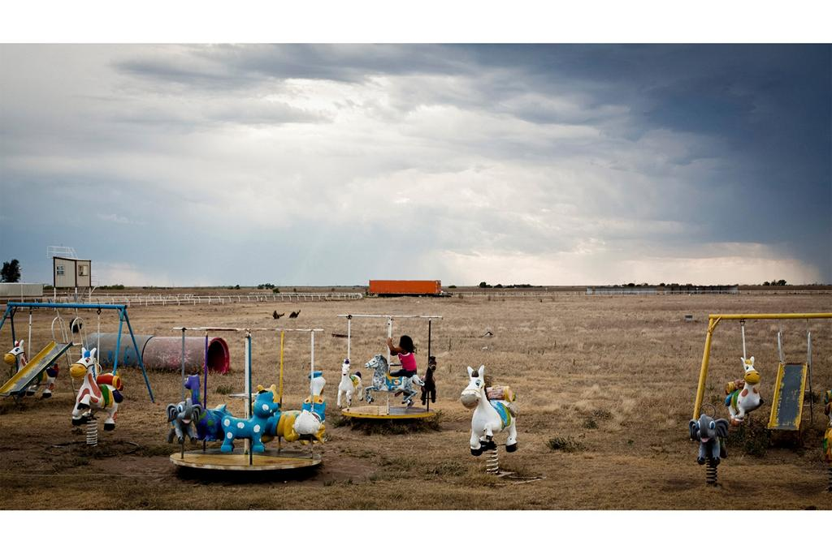

REL 3171: ETHICS IN AMERICA
Spring 2022

Instructor: Anna Peterson
Office: 105 Anderson (Mailbox in 107 Anderson)
Tel. 392-1625, fax 392-7395
E-mail: annap@ufl.edu
Class meetings: T 5-6, Th 6
Room: Anderson 0013
Office Hours: In person, Tues 8th period (3-3:50) and Thurs. 5th period (11:45-12:35) and Zoom by appointment

DESCRIPTION
This class teaches students to reflect on and analyze ethical issues facing contemporary American society. We focus on racial justice, immigration, and religious conflict. As a foundation for thinking about ethical dimensions of these issues, the course will provide an overview of ethics as an academic discipline, including introductions to major ethical theories and thinkers. We will explore the ways that issues such as justice, integration, cultural autonomy, and the common good shape visions of an ethical society. We will also address various obstacles – cultural, economic, and political – that make those visions difficult to achieve.

GENERAL EDUCATION DESCRIPTION AND STUDENT LEARNING OUTCOMES
Primary General Education Designation: Humanities (H)
Secondary General Education Designation: Diversity (D)
Writing Requirement: 2000 words
A minimum grade of C is required for general education credit. Courses intended to satisfy the general education requirement cannot be taken S-U
HUMANITIES DESCRIPTION
Humanities courses provide instruction in the history, key themes, principles, terminology, and theory or methodologies used within a humanities discipline or the humanities in general. Students will learn to identify and to analyze the key elements, biases and influences that shape thought. These courses emphasize clear and effective analysis and approach issues and problems from multiple perspectives. Full description of General Education objectives here.
HUMANITIES SLOs
Full description of SLOs here.
Content: Identify, describe, and explain the history, underlying theory and methodologies used. In this course, students will learn about the theories, and methodologies used in the discipline of religious ethics. Students will study the historical development and current uses of different religious and philosophical ethical theories and the ways they shed light on contemporary social issues in the US. They will read and discuss major theories, thinkers, and issues in this field, learning to understand key arguments and the relations among them.
Critical Thinking: Identify and analyze key elements, biases and influences that shape thought within the subject area. Approach issues and problems within the discipline from multiple perspectives. In this class, students will study important factors affecting the ways people think about the moral dimensions of social issues in the US, including immigration, racial justice, and religious conflict. Students will learn about diverse religious and philosophical perspectives on these issues. They will learn to analyze particular arguments and scholarly conversations in complex and critical ways.
Communication: Communicate knowledge, thoughts and reasoning clearly and effectively. Students in this class will learn to communicate what they have learned clearly and effectively, in writing and orally. The class will strengthen students’ ability to write and talk about moral and philosophical claims in clear, accurate, and comprehensive ways.
DIVERSITY DESCRIPTION
This designation is always in conjunction with another program area.
In Diversity courses, students examine the historical processes and contemporary experiences characterizing social and cultural differences within the United States. Students engage with diversity as a dynamic concept related to human differences and their intersections, such as (but not limited to) race, gender identity, class, ethnicity, religion, age, sexual orientation, and (dis)abilities. Students critically analyze and evaluate how social inequities are constructed and affect the opportunities and constraints across the US population. Students analyze and reflect on the ways in which cultures and beliefs mediate their own and other people’s understandings of themselves and an increasingly diverse U.S. society.
DIVERSITY SLOS

Content

Identify, describe, and explain the historical processes and contemporary experiences characterizing diversity as a dynamic concept related to human differences and their intersections, such as (but not limited to) race, gender identity, class, ethnicity, religion, age, sexual orientation, and disability.

Communication
Analyze and evaluate how social inequities are constructed and affect the opportunities and constraints of different groups in the United States. Analyze and reflect on the ways in which cultures and beliefs mediate understandings of an increasingly diverse U.S. society.

Critical Thinking

The diversity designation is always in conjunction with another category. Communication outcomes are listed in those subject areas.
WRITING REQUIREMENT
This course confers 2000 words towards the Writing Requirement (WR), which ensures students both maintain their fluency in writing and use writing as a tool to facilitate learning. While helping students meet the broad learning outcomes of content, communication, and critical thinking, the instructor will evaluate and provide feedback on students’ written assignments with respect to grammar, punctuation, clarity, coherence, and organization.

Course grades have two components. To receive Writing Requirement credit, a student must receive a grade of C or higher and a satisfactory completion of the writing component of the course.
The writing requirement for this course will be fulfilled by the two short essays. Through writing and revising the papers, and participating in peer review, students will learn to organize their arguments with an appropriate thesis statement, detailed outline, adequate and relevant support for arguments, and clear and correct writing style. In writing assignments, students demonstrate skills in framing arguments, developing plans (outlines), identifying appropriate and accurate support for arguments, and introducing and concluding papers in persuasive and clear ways.
Students will receive feedback from the instructor on the final papers, including comments and suggestions on both content and writing, within 2 weeks of submitting the final papers. This feedback will address content, organization and coherence, argument and support, style, clarity, grammar, punctuation, and other mechanics. The rubric that I use for evaluating all written work is attached at end of syllabus, along with the grading scale. In addition, I will provide specific guidelines for individual assignments closer to the time each is due.
In addition to the feedback from the instructor and the peer review, I encourage you to seek help from the university’s Writing Studio (www.writing.ufl.edu), which offers support for writing in all fields and can be very helpful both in developing your first drafts and in polishing those drafts.
I recommend the Chicago manual of style (https://www.chicagomanualofstyle.org/home.html) as a guide for writing format and style. However, if you are used to following a different style guide, that is acceptable, as long as you check with me first and make sure to use the same format consistently throughout your paper.
Please see rubrics and grading scale at the end of this syllabus.

REQUIRED BOOKS
1. Anthony Weston, A Practical Companion to Ethics, 4th ed. (Oxford, 2019)

2. James Cone, Martin & Malcolm & America (Orbis Books, 2012)

3. Kathleen Sands, America’s Religious Wars: The Embattled Heart of Our Religious Life (Yale, 2019)

4. Miguel de la Torre, The U.S. Immigration Crisis: Toward an Ethics of Place (Cascade Companions, 2016)

Recommended book:
Anthony Weston, A Rulebook for Arguments (Hackett, 2018). ISBN 978-1624666544

REQUIRED ARTICLES AND CHAPTERS (available on Canvas)
June O'Connor, “On Doing Religious Ethics.” The Journal of Religious Ethics 7, No. 1 (Spring 1979): 81-96.

John Winthrop, “City on a Hill” (online)

COURSE REQUIREMENTS
Please Note: The requirements for class attendance and make-up exams, assignments, and other work in this course are consistent with university policies that can be found in the online catalog at: https://catalog.ufl.edu/ugrad/current/regulations/info/attendance.aspx.

Also, please note that a minimum grade of C is required for general education and writing credit.

- Participation. The participation grade will be based on performance in random quizzes (five over the semester), which will be based on assigned texts (10% of final grade).

2. Three short essays (25% of final grade each, total 75%)
a. First short essay, on social ethics. Due Feb. 6. Minimum 750 words.
b. Second short essay, on race and racism. Due March 6. Minimum 750 words.
c. Third short essay, on religious conflicts. Due April 3. Minimum 750 words.
3. Modular Debate on the issues raised by immigration (15% of final grade). This assignment consists of two parts:
a. Short paper: Every student will write a short (about 2 page) position paper in addition to participating in the classroom debate. The grade will be based on your individual paper. Papers are due by midnight on Monday, April 18. (If you fail to participate in the debate but hand in the paper, the paper will count for half credit.)
b. Participation in the modular debate to be held in class on April 19.

I will hand out detailed instructions, but for information on Modular Debates in general, please see http://www.difficultdialoguesuaa.org/handbook/content/technique_modular_debate

POLICIES, RULES, AND RESOURCES
1. Attendance and Participation: Requirements for class attendance and make-up exams, assignments, and other work in this course are consistent with university policies, found in the online catalog at: https://catalog.ufl.edu/ugrad/current/regulations/info/attendance.aspx
Class attendance is required. Do not register for this class if you cannot arrive on time. Students should arrive on time and prepared to discuss the day’s readings. Tardiness harms your understanding of the material and disrupts the class. After the first late arrival, the instructor reserves the right to mark you absent. The instructor will not provide notes or discuss material that has already been covered for students who arrive late, barring extraordinary circumstances (which do not include failing to find a parking place or sleeping in).
Please let me know about any planned absences (for religious holidays, athletic events, or other reasons) as soon as possible. For unplanned absences (due to illness or emergency), please let me know as soon as possible and please provide documentation (e.g, doctor’s note) if possible.

2. Make-up policy: I will arrange for a make-up or early in-class exam only with sufficient notice. If you are out of town when an out-of-class assignment is due, you must email it to me on the date due and then provide a print copy when you return to Gainesville.
If you do not receive an extension from the instructor, assignment will be marked down a half grade (e.g., from B+ to B) for each day late.

3. Completion of All Assignments: You must complete all written and oral assignments and fulfill the requirement for class participation in order to pass the course. I will not average a grade that is missing any assignment or requirement.

4. Common Courtesy: Cell phones and other electronic devices must be turned to vibrate during class (in order to be available for the UF emergency system). Students who receive or make calls during class will be asked to leave and will be marked absent (unexcused) for the day.

5. Laptop and tablet use: You may take notes on a laptop computer, although the instructor reserves the right to ask you to turn off the computer if circumstances warrant. The instructor also reserves the right to ask any student engaging in disruptive behavior to leave the class. If that occurs, the student will be marked absent for the day.
6. Honor Code: The honor code applies to this and all courses taken at UF: “We, the members of the University of Florida community, pledge to hold ourselves and our peers to the highest standards of honesty and integrity. On all work submitted for credit by students at the university, the following pledge is either required or implied: On my honor, I have neither given nor received unauthorized aid in doing this assignment” (https://archive.catalog.ufl.edu/ugrad/1617//advising/info/student-honor-code.aspx).
The university specifically prohibits cheating, plagiarism, misrepresentation, bribery, conspiracy, and fabrication. Any student(s) demonstrated to have cheated, plagiarized, or otherwise violated the Honor Code in any assignment for this course will fail the course. In addition, violations of the Academic Honesty Guidelines may result in judicial action and sanctions, as specified in the Student Conduct Code (https://sccr.dso.ufl.edu/process/student-conduct-code/).
7. Accommodation for Disabilities: Students requesting classroom accommodation must first register with the Dean of Students Office. The Dean of Students Office will provide documentation to the student, who must then provide this documentation to the Instructor when requesting accommodation.

8. Counseling and Emergency Resources: Resources available on-campus for students include the following:
a. University Counseling Center, 301 Peabody Hall, 392-1575, personal and career counseling;
b. Student Mental Health, Student Health Care Center, 392-1171, personal counseling;
c. Sexual Assault Recovery Services (SARS), Student Health Care Center, 392-1161, sexual counseling;
d. Career Resource Center, Reitz Union, 392-1601, career development assistance and counseling.
e. For security issues, please contact the University Police Department: 392-1111, or 911 for general emergencies.

9. Software Use: All faculty, staff, and students of the University are required and expected to obey the laws and legal agreements governing software use. Failure to do so can lead to monetary damages and/or criminal penalties for the individual violator. Because such violations are also against university policies and rules, disciplinary action will be taken as appropriate.

SCHEDULE

Module/Date Topic Reading
MODULE 1: Social Ethics
Th 1/6 Introduction to the class

Tu 1/11 American dreams
Read: John Winthrop, “City on a Hill”
https://www.americanyawp.com/reader/colliding-cultures/john-winthrop-dreams-of-a-city-on-a-hill-1630/
Listen: Anand Giridharadas, “A Tale of Two Americas”
https://www.ted.com/talks/anand_giridharadas_a_tale_of_two_americas_and_the_mini_mart_where_they_collided/transcript

Th 1/13 Getting started Weston, Ch. 1

Tu 1/18 Authority in ethics Weston, Ch. 2

Th 1/20 Ethical theories Weston, Ch. 3

Tu 1/25 Religious ethics O’Connor

Th 1/27 When values clash Weston, Ch. 4

Tu 2/1 Creative problem solving Weston, Ch. 5

Th 2/3 Ethics in practice Weston, Ch. 6

First short essay due on midnight, Sunday, Feb. 6

Module 2: Race and Racism in America
Tu 2/8 Introducing MLK Cone, Introduction and Ch. 1
Listen: King, “I Have a Dream”
https://www.npr.org/2010/01/18/122701268/i-have-a-dream-speech-in-its-entirety

Th 2/10 Introducing Malcolm X Cone, Ch. 2
Listen: Malcolm X, “Message to the Grassroots”
https://www.blackpast.org/african-american-history/speeches-african-american-history/1963-malcolm-x-message-grassroots/

Tu 2/15 A dream or a nightmare? Cone, Ch. 3-4

Tu 2/15 Oral history event: Confronting the Past: Racial Truth and Reconciliation. 5 p.m.
Students may attend and write a short reflection paper for extra credit. Details will be provided in class and at https://oral.history.ufl.edu/.

Th 2/17 Black and white America Cone, Ch. 5-6

Tu 2/22 Shattered dreams Cone, Ch. 7-8

Th 2/24 Two roads to freedom Cone, Ch. 9

Tu 3/1 Race, gender, and class Cone, Ch. 10
Listen: Interview with the founders of BLM
https://www.ted.com/talks/alicia_garza_patrisse_cullors_and_opal_tometi_an_interview_with_the_founders_of_black_lives_matter

Th 3/3 Conclusions Cone, Ch. 11 and Conclusion
Listen: Ruby Sales, “How we can heal the pain of racial division”
https://www.ted.com/talks/ruby_sales_how_we_can_start_to_heal_the_pain_of_racial_division

Second short essay due at midnight on Sunday, March 6

March 7-11 Spring Break

Module 3: America’s Religious Wars
Tu 3/15 Religion as we know it Sands, Introduction and Ch. 1

Th 3/17 Walls and foundations Sands, Ch. 2

Tu 3/22 Religion and citizenship Sands, Ch. 3

Th 3/24 Religion and land Sands, Ch. 4
Listen: The Rise and Fall of the Lakota Empire
https://www.ted.com/talks/pekka_hamalainen_the_rise_and_fall_of_the_lakota_empire
Tu 3/29 Religion and evolution Sands, Ch. 5

Th 3/31 Religion and sexuality Sands, Ch. 6 and Conclusion
Watch: PBS First person: Religion and Sexuality
https://www.pbs.org/video/first-person-religion-and-sexuality/

Third short essay due at midnight on Sunday, April 3

Module 4: Immigration and the American Dream
Tu 4/5 In class: Choose proposition and constituency groups for modular debate
Mexico and Indiana De la Torre, Ch. 1-3
Listen: Juan Enriquez, “A Personal Plea for Humanity…”
https://www.ted.com/talks/juan_enriquez_a_personal_plea_for_humanity_at_the_us_mexico_border

Th 4/7 Anti-immigrant protest De la Torre, Ch. 4

Read: “‘Alt-right’ founder urges Donald Trump to freeze immigration for 50 years”
https://www.independent.co.uk/news/world/americas/donald-trump-immigration-freeze-richard-spencer-alt-right-50-years-demands-a7429666.html

Tu 4/12 Tucson De la Torre, Ch. 5-6

Th 4/15 Mexico De la Torre, Ch. 7
Tu 4/19 Modular debate

Th 4/21 Wrap-up

RUBRIC

Writing Assessment Rubric
This rubric will be used for evaluating all written work in this course.

SATISFACTORY UNSATISFACTORY

CONTENT | Papers exhibit at least some evidence of ideas that respond to the topic with complexity, critically evaluating and synthesizing sources, and provide at least an adequate discussion with basic understanding of sources. | Papers either include a central idea(s) that is unclear or off- topic or provide only minimal or inadequate discussion of ideas. Papers may also lack sufficient or appropriate sources.
ORGANIZATION AND COHERENCE | Documents and paragraphs exhibit at least some identifiable structure for topics, including a clear thesis statement but may require readers to work to follow progression of ideas. | Documents and paragraphs lack clearly identifiable organization, may lack any coherent sense of logic in associating and organizing ideas, and may also lack transitions and coherence to guide the reader.
ARGUMENT AND SUPPORT | Documents use persuasive and confident presentation of ideas, strongly supported with evidence. At the weak end of the Satisfactory range, documents may provide only generalized discussion of ideas or may provide adequate discussion but rely on weak support for arguments. | Documents make only weak generalizations, providing little or no support, as in summaries or narratives that fail to provide critical analysis.
STYLE | Documents use a writing style with word choice appropriate to the context, genre, and discipline. Sentences should display complexity and logical sentence structure. At a minimum, documents will display a less precise use of vocabulary and an uneven use of sentence structure or a writing style that occasionally veers away from word choice or tone appropriate to the context, genre, and discipline. |  | Documents rely on word usage that is inappropriate for the context, genre, or discipline. Sentences may be overly long or short with awkward construction. Documents may also use words incorrectly.
MECHANICS | Papers will feature correct or error-free presentation of ideas. At the weak end of the Satisfactory range, papers may contain some spelling, punctuation, or grammatical errors that remain unobtrusive so they do not muddy the paper’s argument or points. |  | Papers contain so many mechanical or grammatical errors that they impede the reader’s understanding or severely undermine the writer’s credibility.

GRADING SCALE

A | 4.0 | 94-100
A- | 3.67 | 90-93
B+ | 3.33 | 87-89
B | 3.0 | 84-86
B- | 2.67 | 80-83
C+ | 2.33 | 77-79
C | 2.0 | 74-76
C- | 1.67 | 70-73
D+ | 1.33 | 67-69
D | 1.0 | 64-66
D- | 0.67 | 60-63
E | 0.0 | 0-59

For information on UF grading policies, please see:
https://catalog.ufl.edu/ugrad/current/regulations/info/grades.aspx.

Please note:
A “C-“ will not be a qualifying grade for major, minor, General Education, University Writing Requirement or College Basic Distribution credit. You must receive a “C” or better in order to receive that credit.

