How science is really done – or – What do scientists do all day?
By Andrew R Zimmerman, Department of Geological Sciences, University of Florida
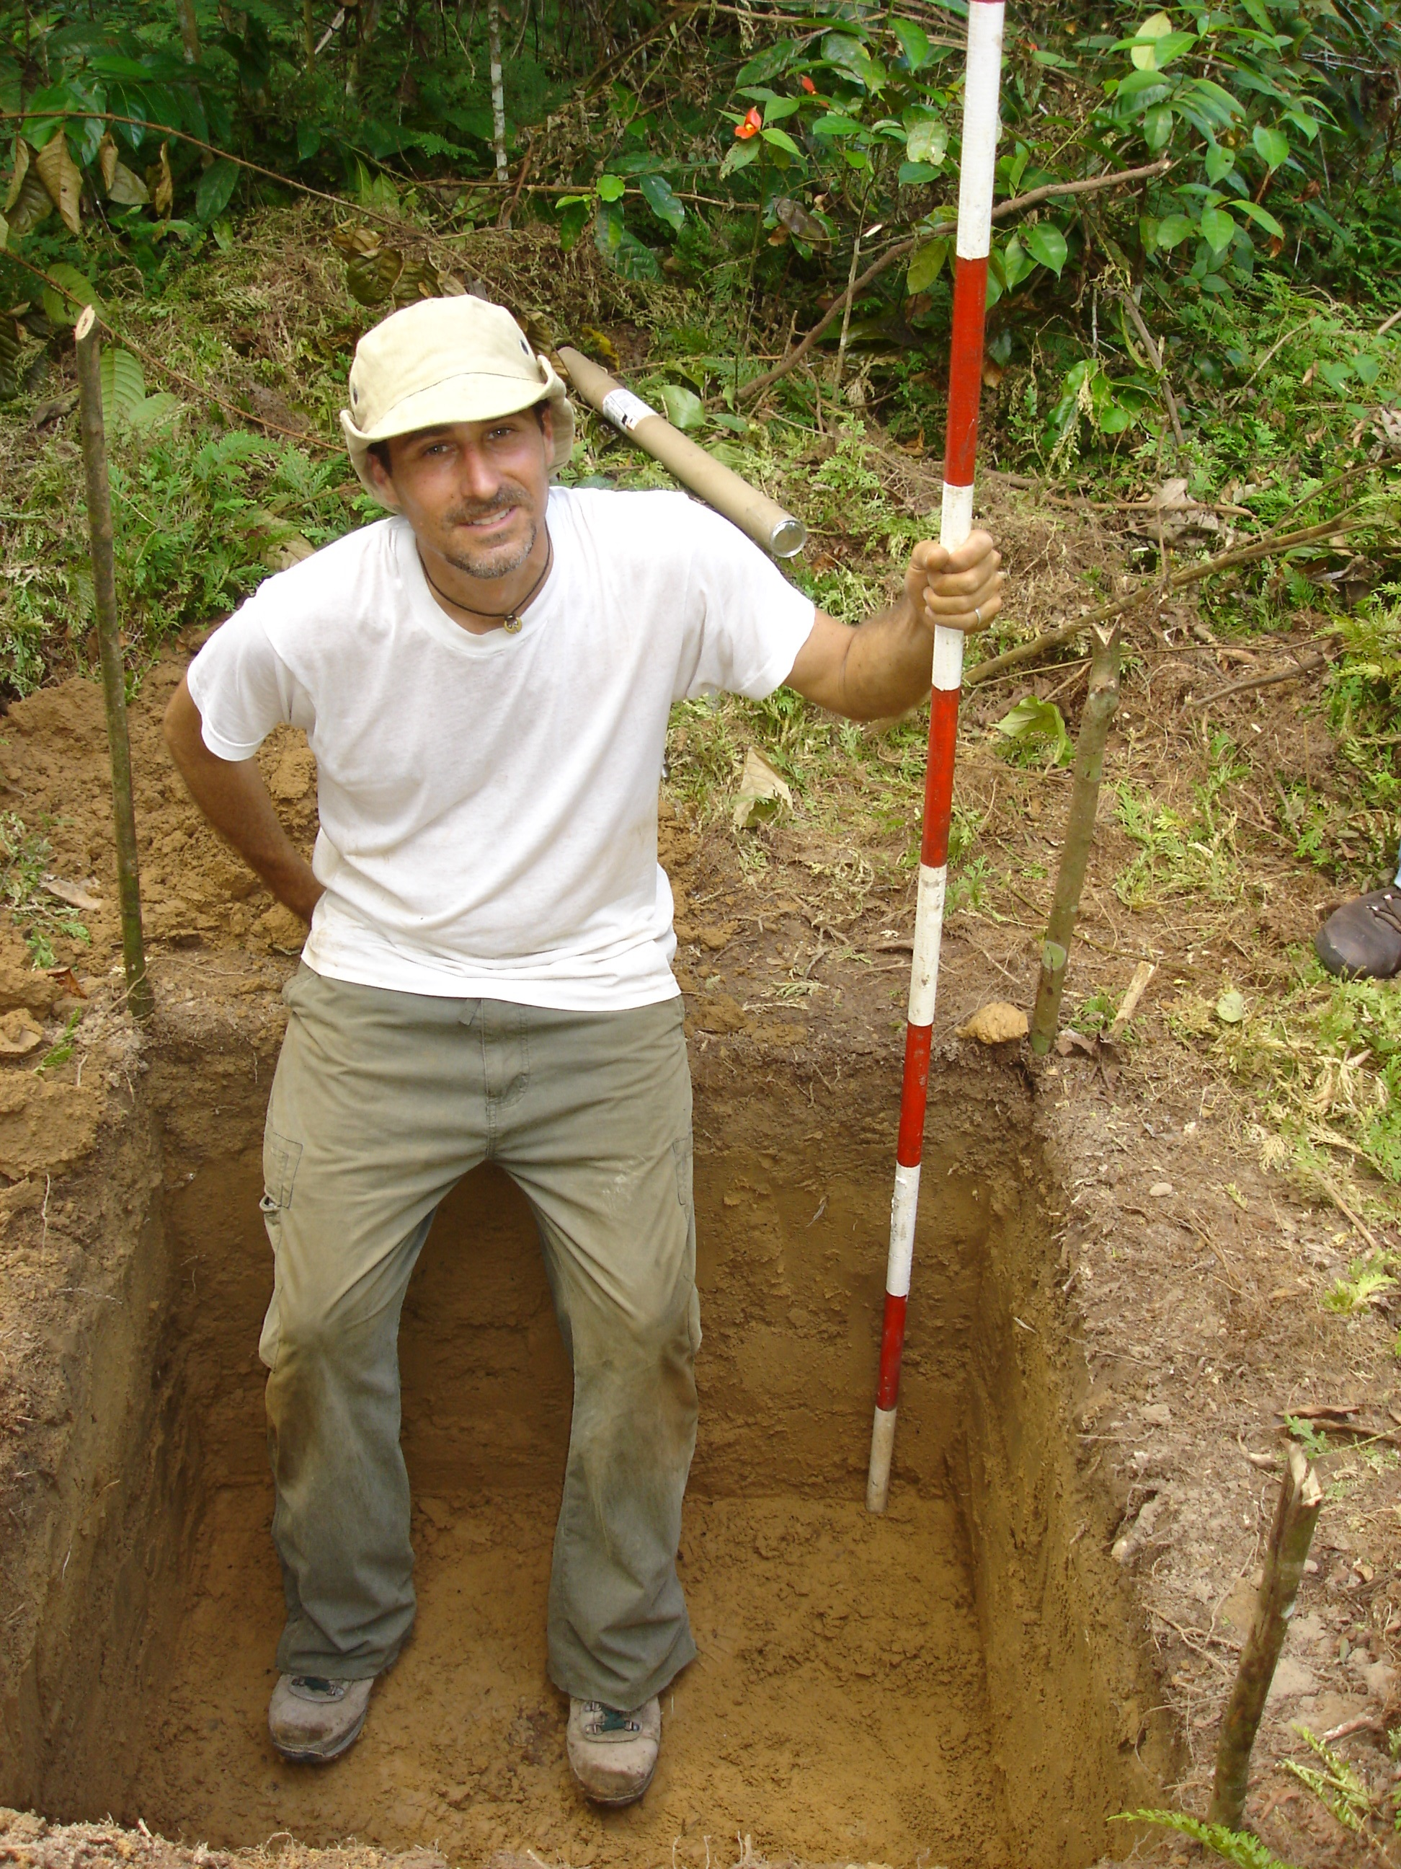
I wanted to provide for my students some description of the ‘reality’ of being a scientist today. But after an exhaustive search on the web and in books and journals, I came up with very little. Very little except sanitized, idealistic praise for the long-toiling explorers of the unknown, driven by curiosity and altruism. So I decided, somewhat reluctantly, to write my own unauthorized account. First a disclaimer; this comes mainly from my own experience. As such, it applies in large part to scientists in higher education in the U.S. Also my own experience is inevitably skewed toward that of the Earth/Environmental scientist. There are so many kinds of scientists doing so many things. According to the National Science Foundation (NSF), there were about 5.4 million people employed in science and engineering (S&E) occupations in the U.S. in 2013 (72% male, 70% in science and 30% in engineering). Of those that have received a PhD, about 40% work in industry and about 46% in higher education. Other scientists may work for the federal government (6%), a non-profit (%7), or state and local governments. But I have here endeavored to describe the most typical experience, which also, I think, happens to be similar to my own. This exposition is not about the ‘scientific method’ or the details of how to do experiments, write scientific papers, or get funded. But rather, it outlines the steps that we, as scientists, typically go through in our daily professional life. None of this will be news to any working scientist. But I thought this information might be useful to those considering science as a career and perhaps to non-scientists, as it may shed light on the biases and motivations from which scientific results, reported to you in the press every day, emerge (in politics, I believe they call ‘the sausage making’).
OK, suppose you find yourself as a new professor in some science-related field at a college or university. Most likely, you have gone through your undergraduate and graduate school student years and received a PhD. You have also likely put in 2-5 years as a post-doctoral researcher somewhere and applied and interviewed at numerous institutions until, finally, you were offered a position. The job probably comes with start-up fund for buying equipment (ranging from several thousand to a few million dollars) and an annually renewed contract, provisional upon satisfactory progress toward making yourself a productive researcher (and an acceptable teacher and mentor). After about seven years, a professor will be judged by his or her department, college, and university (in sequence) on whether he or she should receive tenure (defined as the status of permanent employment – assuming no major issues come up (such as being convicted of a crime or extreme moral failings). All faculty are expected to participate to different degrees, depending upon the university and the particular job, in the areas of research, teaching, mentorship and service. To get tenure, one must achieve distinction in at least two areas, but research is typically the most important.
Teaching. Let’s leave research aside for a moment. Science faculty are expected to teach anywhere between one and six classes each year. Three is probably most typical and these could be lower or upper level undergraduate or graduate classes, probably a mix of these. On paper, we spend about 30% of our time teaching but in reality, it is probably more like 10-20%, unless we are developing a new course. For many, teaching students, particularly undergraduates, is simply a diversion from what they would rather be doing while for others, it can be a refreshing and stimulating change from the highly technical and specific research problems upon which they are currently focused.
Service. Fulfillment of service expectations could be achieved by sitting on one or several department or university committees, service to the community by carrying out various types of outreach or advisement activities, or service to the profession by editing journals, reviewing papers or proposal, or sitting on boards of professional organizations.
Mentorship generally means serving as the advisor, and perhaps provider of salary and funds, to graduate students and, in some cases, undergraduate or post-doctoral researchers. Achievement in this area might be judged by how many students one sees through to obtaining their terminal degree or getting a job in the field.
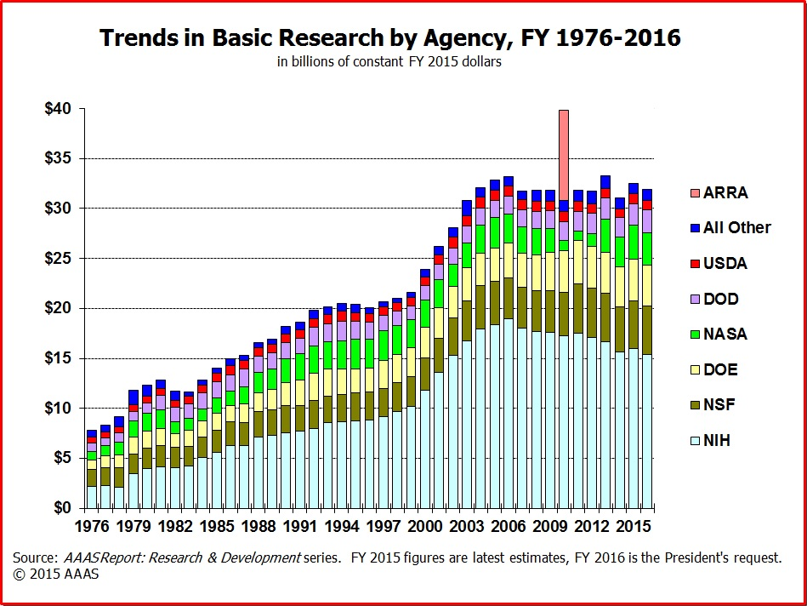
Research. For university officials who evaluate science faculty, research is probably the most important activity in which they judge achievement as this is what brings notoriety and money to the university. The first steps of the scientific method may be ‘make observations’, ‘ask questions’, ‘construct hypotheses’, but the real first step of a professional scientist is probably to ask oneself, what area of research in my field is hot right now? What research idea can I get funded and where? One might look through listings of RFPs (Requests For Proposals) put out by various governmental funding agencies such as NSF, NOAA, EPA, NASA, USDA etc., to see if any of their areas of interest correspond to one’s research expertise.
Once an appropriate funding program has been identified, the next step is often to gather a team of scientist to join you in writing the proposal. Doing science has become more and more of a collaborative activity as the questions to solve have become more complex, requiring solution using a multi-disciplinary and multi-tool approach. Often, the collaborators are located at different institutions, or even in different countries. So proposal writing, which, if successful is followed by research and paper writing, is typically done on e-mail (passing versions back and forth), interactive tools for conferencing such as skype, and file-sharing sites such as google.docs or dropbox.
A research proposal must be written in strict accordance to the format specified by the particular funding agency, but it is typically about 15 singe-space pages. The proposal typically starts with background to some research question, i.e. a review of the literature, leading up to a claim of there being some important knowledge gap in a certain area that needs to be filled. Then the proposal will present hypotheses and describe a method of testing those hypotheses. Next is a description of how the proposed research would be of direct or indirect societal benefit, and could include descriptions of other details such as training of students (particularly those of under-represented groups in the sciences), outreach activities (e.g. creating a website or museum exhibit etc.). These “broader impacts” have recently become a more important and necessary portion of a successful research proposal.
Each proposal must also supply biographical sketches of the participants, listing of equipment at hand, and other documentation of the ability of the scientists to carry out the proposed research. It also must include a budget, the construction of which requires the scientist to be part accountant, part diplomat, and play the game of guessing how much is reasonable to ask for, i.e. enough to do the work cost effectively but no more. Research grants can run from about $50,000 for small projects to several million dollars for big multi-institution grants. For the National Science Foundation, (NSF), the average award is about $400,000 for a 2-3 year project ($150,000 per year). Of this, about 50% goes to the scientist’s institution for ‘overhead’ (keeping the lights on so to speak, administration, etc.), about 40% for salaries for faculty and students and tuition, and about 10% for supplies to do the actual research and perhaps travel funds to attend meetings.
While each funding agency is somewhat different in how they decide which proposal to fund, here I will describe the NSF proposal review process. The program manager, a government employee, sends each proposal out to about five expert scientists to read and rate. Then, about twice a year, the program manager calls together a review panel consisting of about 12 scientists in the general field, typically those that have been funded by the program previously. These scientists will read and rate about 10-20 proposal as well as all the external reviews of each proposal. When the panel meets, they discuss the relative merits of all the proposals and rank them from most to least worthy of funding. While one might think it is their job to judge each proposal on its scientific merits alone, other factors do come into play such as the reputation of the proposing scientists, how much funding they have gotten in the past, and certainly the scientific biases of the panel members themselves.
Of the roughly 60 proposals a panel reviews, about 10-15 are funded. Across NSF, the proposal success rate is 20%, on average (closer to 10% in some programs), down from 30% 15 years ago. This means a scientist must submit about 2-3 proposals before getting one funded. Several resubmissions of rejected proposals are allowed.
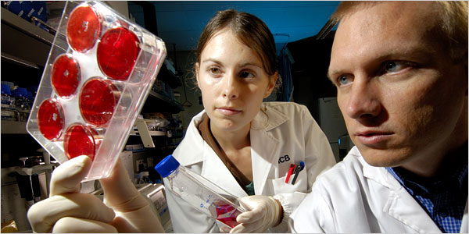
Once successful, it’s time to get to work. I won’t go into great detail here about actually doing the research except to say that it is typically a graduate student or post-doctoral researcher or other hired hand that does the majority of work in the field or lab, collecting samples or making observations, running experiments, etc. The lead scientist is responsible for meeting with these workers, overseeing their progress, managing the research budget, giving advice when needed. They must submit annual project reports to the funding agencies. The work done does not have to strictly correspond to that described in the proposal as unexpected events or new findings often necessitate a change in direction. But the research must show tangible results, typically in the form of presentations made at professional conferences and published papers.
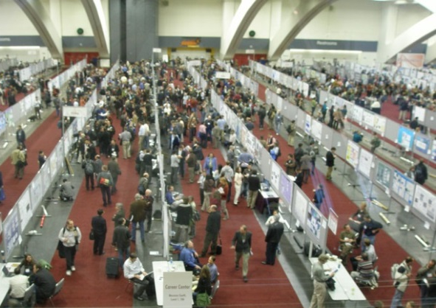
A scientist is likely to go to one or several conferences each year. At these meetings, the scientist and/or their students present their most recent findings orally or in the form of a poster. But the main value of attending these conferences is the chance to see what everyone else is doing, discuss ongoing projects with collaborators or talk with other scientist to get ideas, or to form new collaborations for future funding proposals.
Publishing. You’ve likely heard the adage ‘publish or perish’. This comes from the fact that the predominant currency by which scientists in academia are evaluated is in publications. This evaluation can be done by counting the number of their publications in peer-reviewed journals (more on peer-review shortly), but also by the quality of their publications. ‘Quality’ can be judged by the stature of the journal in which they are published (for example Science and Nature are the most highly ranked), but one can also look at the number of times a paper was cited by others. In this case, it may take a while for the quality of a paper to be realized.
Writing papers for publication is also typically a collaborative activity, one which may occupy a good portion, if not the majority of a scientist’s time. Often a graduate student might start the process with an outline which would include the figures and data tables (which really, in themselves, can tell the story). After discussing this with their mentor, the student may be sent back to work on the first draft. There may be many rounds of manuscript versions sent back and forth between the student and their mentor before reaching a version good enough to be sent out to other collaborators for comments. When these come back and suggestions are incorporated, the manuscript is ready to be submitted to an appropriate journal, chosen based upon where the scientists think it will be most read by the most interested audience. If they think it is an extremely important finding, they may try submitting it to a widely read journal like Science or Nature. While most journals will send each submitted paper out to other scientists for review, the editors of the most prestigious journals will pre-screen submissions and only send out the ones they consider to be of highest impact. The journal Nature, for example, only publishes about 8% of the 200 papers submitted to them each week.
Peer-review is a odd process. An editor might have to ask many scientists to review a manuscript before getting 2-5 willing to do so. How does a scientist choose which papers to review? The idealistic answer is: they papers in which they feel themselves to be most qualified and interested in the subject matter of the paper. The pessimistic answer is: they review papers on subjects in which they feel themselves to have a stake, that is, because they were intending on publishing on the same topic or they have an axe to grind. The hope is that, by getting reviews from enough scientist, the editor can identify these biased reviews and make their decision based upon the majority view. This is becoming more of a problem as editors are increasingly having a difficult time finding more than one or two reviewer willing to take on this essentially thankless large donation of time and effort. Few have the time to thoroughly review papers that can be quite lengthy and complex. Another problem with this system is that, in efforts to get papers accepted, few ancillary observations or negative results are likely to get published.
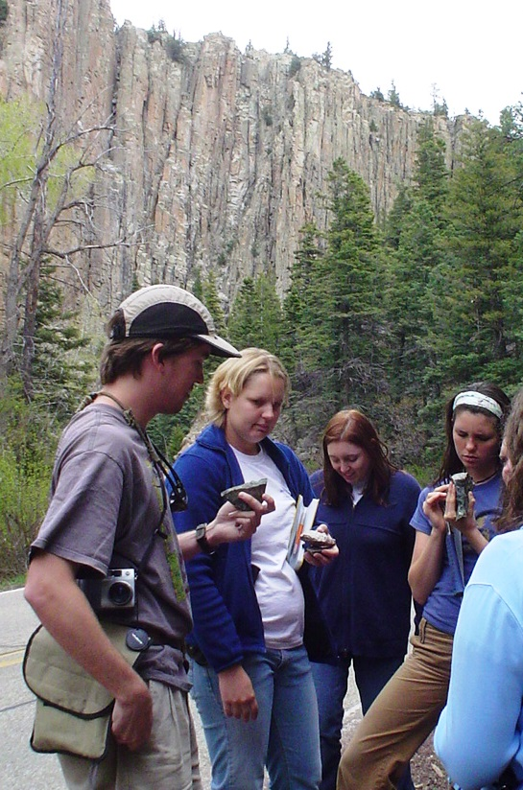
After collecting all reviews, the editor will make the decision to either accept or reject or ask for a revised resubmission of the manuscript. The latter is the most common result and in this case, the authors must respond to each of the reviewers comments, either making the suggested changes to the manuscript or making an argument as to why they are refusing to do so. Then the manuscript goes back to reviewers for comment, and then the editor for a final decision. The whole process from submission to final rejection or publication is likely to last almost a year, during which time the authors have likely moved on to research on different topics and suffered through considerable, usually polite, but sometimes harsh criticism.
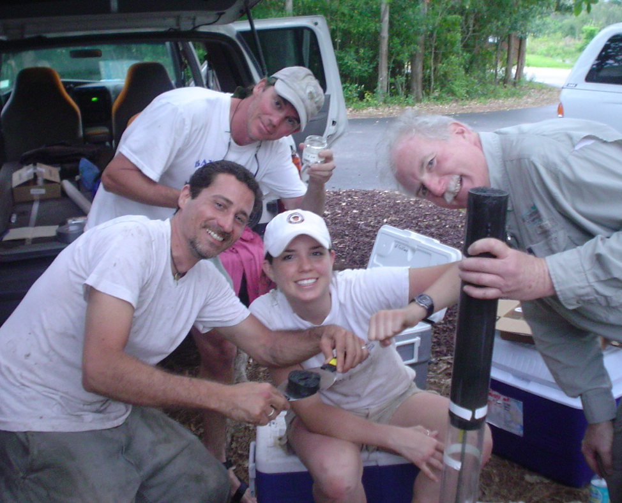
Rewards. I hope this essay does not give the impression that doing science is nothing but a pain in the butt. There are many major rewards. Foremost is probably the feeling of discovery. This can come slowly over time or in a flash, when a key observation or realization is suddenly made. It feeling can be quite euphoric. Doing science is also an adventure, sometimes one of the mind, sometimes a very real one. For many scientists, the varied experiences we have when we do field work, travel for conferences, or work with scientists from other countries is a major part of what draws us to science. Another type of rewarding experience, common to all teachers, can be had when we see a light bulb suddenly go on in a student we are teaching or mentoring. What about the pay? According to The Chronicle of Higher Education, the average salary of science faculty at 4-year colleges and universities in 2011 was about $90,000, $68,000 and $58,000 for full, associate and assistant professors, respectively. For comparison, the average was about 20% higher for engineering faculty and about 10% lower for faculty in the humanities. Scientists in industry earn about 50% more on average. However, most in academia consider the reduced pay to be worth the greater freedom they have in research topic selection and schedule. A further benefit not often considered, is that it can be much more pleasant to work with and amongst those who have chosen their career based upon passion rather than those driven by attainment of money or power. Consideration of quality of life and those who would be my peers is, in fact, why I transferred my major from pre-medical to geology as an undergraduate. I have no regrets whatsoever.
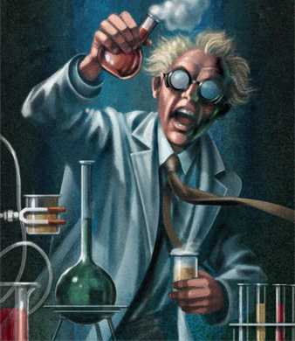
Final Thoughts. Through all these travails, all scientists understand that this is the scientific process. One has to develop somewhat of a hardened shell to suffer such continuous criticism and rejection. Of course, there are ‘super-star’ scientist who, through their intellect and often, force of personality, receive well more than their share of funding, prestigious publications, and recognition. The majority of scientists probably feel that they are slogging it out in the trenches, incrementally pushing forward the boundaries of knowledge. But we have put our faith, or at least tolerance, in this system that is designed to result in a fair hearing of ideas and merit-based distribution of the available resources. Every scientist has their complaints about this system but no one has come up with a better one.
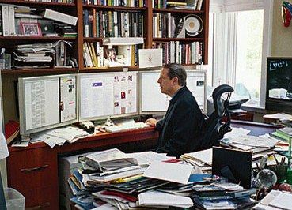
So what do scientists really do all day? For scientists at universities the answer is mostly the same as what I suspect most all white-collar workers are doing, sitting at a desk, working on a computer. That is, we are writing proposals, manuscripts, e-mails, lesson plans, editing manuscripts, working with data, reading published papers of others (downloaded as pdf files). But we also spend a good chunk of time meeting with people; students, collaborators, department and university committees. Maybe this is not as glamorous as the image that the layman has of scientist, toiling away in a lab alone, or slogging through the jungles of Borneo in search of the one piece of evidence that will immediately make us famous. But at the same time, the truth should not be discouraging to those interested in becoming scientists. We perform a variety of tasks through the day requiring people skills, computer skills, mechanical and artistic ability, accounting skills, communication skills of all types. In some ways, we are small business operators, in others, we work for a type of large (non-profit?) corporation or government entity. It’s a particularly engaging way to spend the day, so much so that I often miss appointments or come home to my family later than promised because I was lost in my work. On the whole, I am guessing most of us love what we do because, in all these tasks, we are always using and sharpening our brains. We are learning more and more about the world around us and training others to do so. This is what scientists really do all day.

Ray
1. One of the things that makes the 'slog' worthwhile is the feeling I get at the 'discovery moment,' the moment when - after all the grunt work - I first see the new, positive results. For me this is usually in graphical form - new figures, and it is undeniably emotional.
2. For us, maybe not most: the importance of field work and all the varied experiences that go along with that: being outdoors, and all the 'adventures' that often entails; being abroad, and all the cultural sensitivities one must develop in order to work successfully with scientists from and in another country. I get a lot of job satisfaction from this.
3. You don't mention salary anywhere. (Says something very admirable about you!) But perhaps it should be pointed out to those considering science as a job that the academic version is paid less, based on the assumption (?) that we do it for love or ego.
Best,

What is the message from all of this? A few things may be surprised to have learned:
- Most scientists spend most of their time at their desk, writing proposals and paper, not in the field or laboratory
- The direction or progress of science, what get researched and what gets published, is guided (or even one might say ‘gate-keeped’) by other scientist, through proposal and paper review.
- A scientist must do a wide range of jobs besides that of ‘doing science’ including budget manager, mentor, editor, and above all, writer.

-funding; How to apply, who gets funded? How much? Who decides?
-little for replication
-const. 10% of domestic discretionary funding, more scientist (universities see it as essential revenue source so grow programs), success rate has decreased to about 15%
- peer review (unpaid, few spot mistakes)
- publishing (high rejection rates, only ‘striking findings’, few negative results)
- Sources, Primary, secondary, tertiary
-meetings/collaboration
- How do people become scientist?
-tenure, evaluations (teaching, service, research – citations, pubs)
- Working in academia: graduate students, other duties
-bias
-the scientific method in reality (hypoth not desirable because they will tend to bias experimental design and analysis) (The actual work is often not nearly as organized and logically done as the papers indicate!! The so-called “scientific method” reflects how science is published, not necessarily how science is done.)

Constraints on solving problems
Scientific Integrity – (you should report everything that you think might make conclusions invalid – Details that could throw doubt on your interpretation must be given)
Competition

http://www.nsf.gov/statistics/infbrief/nsf13311/

