Learning Manual for Assessment of
the Virtual Anesthesia Machine

Version TR 1.1
7/13/06





Learning Manual for Assessment of
the Virtual Anesthesia Machine

Version TR 1.1
7/11/06

During today’s session, you will be learning about how an anesthesia machine works by using a computer simulation of a typical anesthesia machine. The training involves four stages:

- Read an overview of the purpose, function, and structure of the anesthesia machine, designed to give you a framework for understanding the material that follows
- Take a tour of the main subsystems of the machine, and the components and controls of each system, through the simulation
- Focusing on some of the subsystems, learn the answers to several specific questions about the operation of the machine and control of anesthesia, with step-by-step instructions for using the simulation to answer them
- Try to answer several other questions by using the simulation

Tomorrow, we will try to assess what you learned about the machine, and how well you learned it.
1. Overview of anesthesia and the anesthesia machine

General Anesthesia

General anesthesia is the induction of a balanced state of unconsciousness, accompanied by the absence of pain sensation, and the paralysis of skeletal muscle over the entire body. It is induced through the administration of anesthetic drugs and is used during major surgery and other invasive surgical procedures.

General anesthetics may be gases or volatile liquids that evaporate and are inhaled along with oxygen and other atmospheric gases. The amount of anesthesia produced by inhaling a general anesthetic can be adjusted rapidly, if necessary, by adjusting the anesthetic-to-oxygen ratio that is inhaled by the patient.

Functions of the Anesthesia Machine

- Get gases from supply lines
- Measure their pressure and flow, and load them with anesthetic vapors
- Present them to the patient for breathing
- Breathe for the patient, if necessary
- Maintain an appropriate mixture of gases being breathed, adding oxygen and removing carbon dioxide as needed
- Provide an exit route for gases

Main subsystems of the Anesthesia Machine:

- The gases are supplied by a high pressure system.
- An adjustable low pressure system reduces the pressure, and mixes the gases along with the anesthetic vapors.
- Since paralysis is a consequence of general anesthesia, breathing is usually controlled by a manual breathing system, in which the operator squeezes a bag to deliver gases to the patient, or…
- by a mechanical breathing system, in which a bellows is alternately filled with gases, and emptied into the airway.
- The breathing circuit connects the patient to the anesthesia machine, of course, and controls the flow of gases during inhalation and exhalation.
- Finally, the exit route for gases is provided by the scavenging system.

The Virtual Anesthesia Machine: A “transparent simulation”

In learning about the function of the anesthesia machine, it is important to be able to visualize how the various gases flow through the system, and how the different subsystems interact to control that flow. The Virtual Anesthesia Machine was intended to give you that “under the hood” view of the operation of the machine. The ability to see the dynamics of gas flow helps you build a “mental model” of the machine, and understand how it does what it does. It also helps you understand what can go wrong with the machine, and respond to unexpected faults.

Because of the importance of visualization, be sure that you take advantage of this aspect of the simulation, carefully observing the consequences of your actions on gas flow, both locally within that system, and globally in other systems. Use the simulation to try and study what’s happening to gas pressure and flow under various conditions.

In the exercises that follow, you will learn more about some of the components and functions of the anesthesia machine by using the Virtual Anesthesia Machine (VAM) simulation to answer a set of questions about three of the subsystems that are central to its function:

- The breathing circuit
- The manual ventilation sub-system
- The mechanical ventilation sub-system
2. Introduction to the VAM and its components

We begin with a “grand tour” of the anesthesia machine simulation to familiarize you with the location of the major subsystems, and the controls and structures of those subsystems. As you work through the tour, try to imagine how each subsystem and component might operate in conjunction with the other parts of the machine.

The major subsystems:

____ Click on Help Using VAM (in the orange column to the right of the screen):

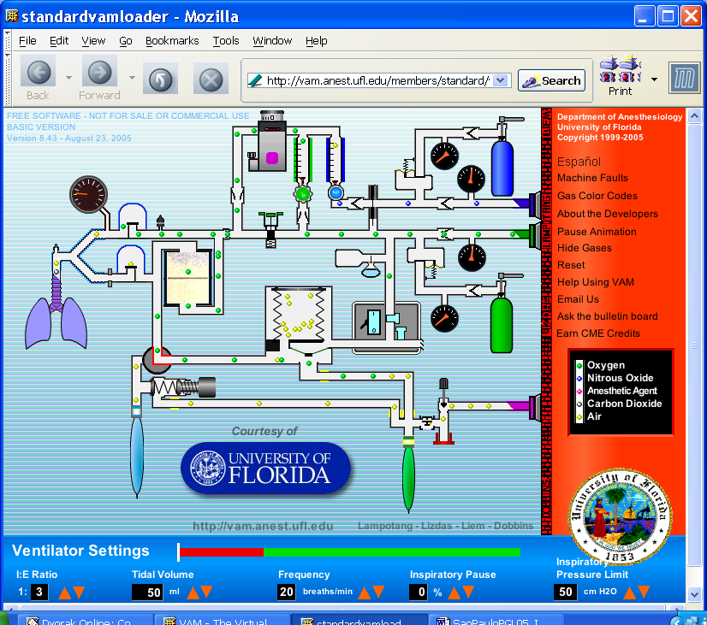

____ Click on the green arrow to see each of the component subsystems:

- High pressure system. For both Oxygen (O₂, GREEN) and Nitrous Oxide (N₂O, BLUE), note there are two sources – pipelines from the wall, and cylinders as backups.
- Low Pressure system. Includes controls for flow of these gases, and the anesthetic agent (in the purple-marked vaporizor)
- Circle System Breathing Circuit. Includes paths for inhalation (upper valve), exhalation (lower valve), and the CO₂ absorber for “scrubbing” or absorbing carbon dioxide from the gas. Why is this called a circle system?
- Manual ventilation system. Basically a squeeze bag, and a valve that keeps the gas pressure from getting too high during manual ventilation (the Adjustable Pressure Limiting, or APL, valve). Note the position of the red ventilation selector switch. This controls whether ventilation is under manual or mechanical (automatic) control.
- Mechanical ventilation system. Note the large bellows in the middle. As this is compressed, gas is pushed into the lungs; then, as the lungs deflate, it’s refilled with gas from the lungs and some fresh gases from the low pressure systems.
- Scavenging system. There’s a constant, low-pressure suction to remove excess gases from the system. The waste gas scavenging bag fills up during exhalation, and deflates during inhalation. What are the inputs to the scavenging system?

Interactive User Controls

____ Click the green arrow to see each control. The controls that you will be using in this lesson are highlighted in red. Consider the function of each in the machine and try to imagine its operation:

- Oxygen cylinder supply. Contains enough oxygen for a limited amount of respiration. (Time to exhaustion of the cylinder depends on the consumption rate, which can be very variable. A full cylinder contains 660 L of O₂).
- Oxygen pipeline supply. This is delivered from a remote central supply (actually liquid O₂ at UF).
- Nitrous Oxide pipeline supply.
- Nitrous Oxide cylinder supply.
- Nitrous Oxide flowmeter knob. In the simulation, you control gas flow by a left-click-and-hold, then drag the knob counterclockwise to increase flow. Note the position of the “bobbin” in the flowtube. The higher the bobbin, the greater the flow.
- Oxygen flowmeter knob. Note the position of the bobbin for Oxygen. Is it the same as for the Nitrous Oxide?
- Vaporizer dial. The vaporizer contains liquid volatile anesthetic, the dial controls how much is vaporized and added to the gas mixture.
- Vaporizor fill cap. This is used to refill the vaporizer when the liquid anesthetic level becomes low.

- Oxygen flush valve. This valve allows oxygen to flow directly to the patient, bypassing the vaporizer and flowmeters. It is used to quickly increase the amount of oxygen and decrease the anesthetic concentration in the system.

- Selector switch. Selects manual or mechanical ventilation. Which position is which?
- APL (Adjustable Pressure Limiting) valve. Can be fully open, fully closed, or set to open at a threshold pressure, effective during manual ventilation only.
- Manual breathing bag. What will happen when the bag is squeezed if the APL is closed or open? What will happen when the Selector Switch is set for mechanical versus manual ventilation?
- Ventilator switch. Turns on mechanical ventilation, compressing the bellows at a selected breathing rate.
- Scavenging adjustment valve. Controls the outflow created by the Scavenging vacuum.
- Wall vacuum plug. Provides a vacuum source and removes the scavenged gases to prevent room pollution.

C. Other Key Components

- Airway pressure gauge. Given its placement between the inspiratory valve and the lungs, what would happen to the pressure if the patient tried to inhale, or exhale, with the inspiration and expiration valves of the breathing circuit closed?
- Inspiratory valve. Opens up when the pressure in the airway is less than the pressure on the other side of the valve (as during inhalation, or inspiration); note it’s unidirectional, and gases can’t flow in the opposite direction.
- Expiratory valve. Also unidirectional, but in the opposite direction. Opens when the pressure in the airway is greater than the pressure on the other side of the valve. Try to visualize their operation during respiration.
- CO2 absorber. Scrubs the gas of carbon dioxide during inspiration.
- Common gas outlet checkvalve. Prevents retrograde flow from the circuit (especially if the circuit is at high pressure) back into the vaporizer which could lead to higher than intended volatile anesthetic concentrations and overdose. (Not all anesthesia machines have this valve.)
- Oxygen failsafe. Automatically shuts off flow of N2O if the O2 supply pressure drops below a threshold, so that a hypoxic gas mixture is not delivered.
- Pressure regulators. One for each of the two input gases, steps the pressure down from high to low pressure systems.
- Pressure gauges for each of the four possible sources of gas
- Low oxygen supply pressure alarm. Warns that the oxygen supply pressure has fallen below a set threshold and will soon fail or has failed.
- Ventilator proportional flow control valve. Part of the mechanical ventilation system. Opens during mechanical inspiration to pressurize and drive the bellows down.
- Ventilator Pressure Relief (VPR) valve. Part of the bellows system. Also called the “spill” or the “pop-off” valve). Allows excess gases to be discharged, once exhalation is at an end, and the bellows have re-filled.
- Scavenging positive and negative pressure relief valves. As the names imply, keeps the pressure within the scavenging system within a designated range.

D. Interactive Ventilator Settings.

These control various aspects of the mechanical ventilation sub-system:

- The I/E ratio is the proportion of time spent inhaling (Inspiration, I) and exhaling (Expiration, E). Think of your spontaneous breathing cycle. What seems to be the “natural” ratio? Note that there is a short time between exhalation and the next inhalation; this is called the end-exhalation period, and is included in the E interval, as you’ll see in the simulation.
- Tidal volume, in mL, is the total volume of gases inhaled during inspiration.
- Frequency of breathing, in breaths per minute.
- Inspiratory pause. During mechanical ventilation, a user-adjustable pause may be added between active inflation and the start of exhalation.
- Inspiratory Pressure Limit. Prevents over-inflating of the lungs during mechanical ventilation. Current standards set this at a default of 40 cm H2O.

____ Click the X in the upper right corner of the window to close the “Help using VAM” module.
3. Exploring the Virtual Anesthesia Machine

In each of the sections below, we begin with a question about the function of the machine, and using the simulation, demonstrate and explain the answer, addressing other questions that can be illuminated by the VAM along the way.

As you read each of the questions in italics, try to answer it by first looking at the simulation, watching the “dynamics” of gas flow and the operation of relative components, before reading the answer.

Be sure you understand the explanation, in terms of visualizing the machine operation, before moving on to the next question. The controls you operate on are indicated in screen shots.

A Preview of the Exploratory Questions.

Here are the five main questions that you’ll be answering during the tutorial:

Question 1: elimination of CO₂. Are the gases exhaled by a patient “scrubbed” of CO₂ before entering the bellows during mechanical ventilation?

Question 2: changes in fresh gas flow concentration. You are anesthetizing the patient with a concentration of 30% oxygen (O₂) mixed with 70% nitrous oxide (N₂O). In preparation for emergence from anesthesia back into consciousness, you turn off the N₂O flow to set the O₂ concentration to 100%. Is your patient now breathing 100% O₂?

Question 3: elimination of excess gases. What is the exit for gas during the inspiratory phase of mechanical ventilation?

Question 4: flushing with oxygen. Why should you not flush during mechanical inspiration?

Question 5: The APL valve. The adjustable pressure-limiting (APL) valve is closed after switching to mechanical ventilation for maintenance of anesthesia. Switching back to manual ventilation for emergence from anesthesia, you forget to adjust the APL valve, and squeeze the manual ventilation bag. What happens?
A roadmap and some reminders.

Before beginning, there are some basic aspects of the simulation that are worth pointing out:
- The system can always be reset to the start conditions by clicking the word RESET in the orange column at the right (See the screen shot below)
- Pointing to many components will “pop up” a picture of what the component or control actually looks like on the typical anesthesia machine. This appears in the lower right of the VAM screen. In the screen shot below, we’ve “moused over” the carbon dioxide absorber, part of the breathing circuit, Try this on a couple of the icons.
- The color code for the gas molecules is also displayed on the lower right, so if you forget which is which, you can look there for a reminder. Note that room air, even though it’s a complex mixture of gases, is represented as a single kind of gas, in yellow.

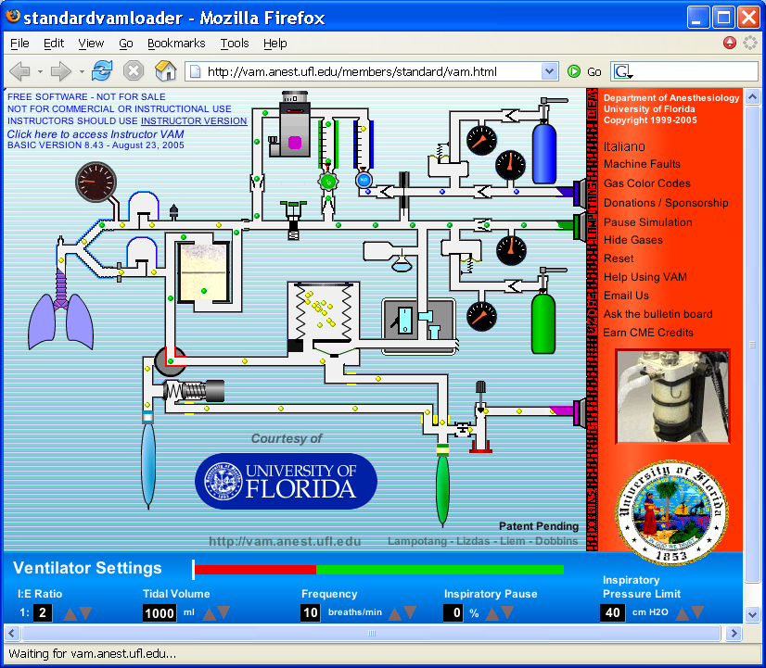
Question 1: elimination of CO₂. Are the gases exhaled by a patient “scrubbed” of CO₂ before entering the bellows during mechanical ventilation?

Demonstration using VAM Simulation:

____ Click “Reset” to start simulation afresh

____ Point to the O₂ flowmeter control knob to enlarge it, then click-and-hold, and drag it counterclockwise until the O₂ bobbin inside is about halfway up the tube.

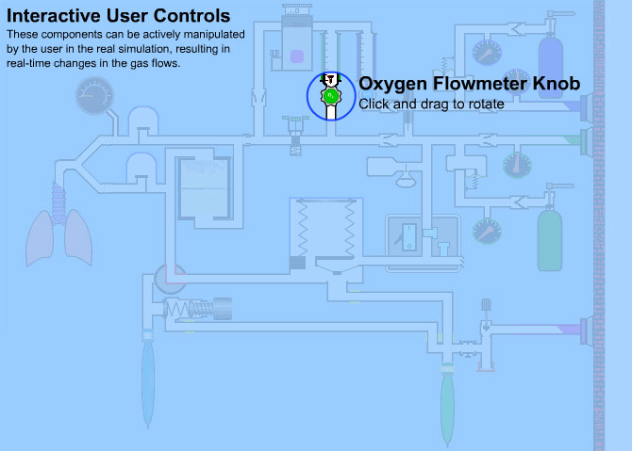

What does this do? What happens to the flow of O₂ from the supply line?

Opening the valve increases the flow of O₂ from the supply line into the breathing circuit.

Trace along its route through the plumbing. Where does it wind up?

It depends. For example, If mechanical ventilation is selected, but not on, the O₂ flows “backward” through the CO₂ absorber, past the bellows and into the scavenger system
____ Click on the ventilator on/off switch icon to turn on the mechanical ventilation system. The patient is now being automatically ventilated by the mechanical system.

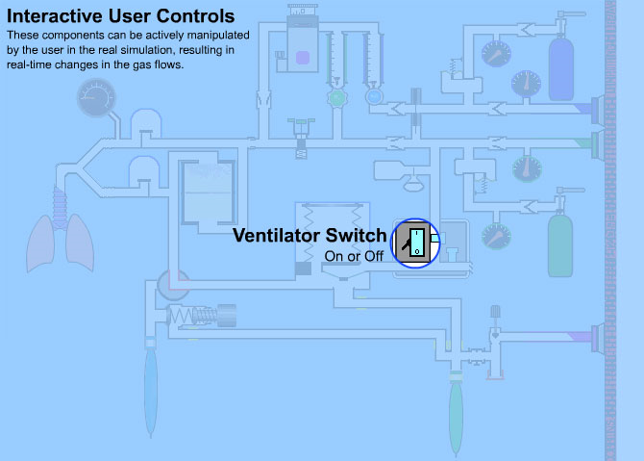

Notice what’s going on during inspiration, as opposed to exhalation, as you scan through the simulation and observe the flow of gases. Study it until you feel you have some sense of what’s happening. Then verify the following, trying to answer each question by looking at the VAM before reading the answer:

During inspiration:

What powers the bellows?

O₂ flows into the bellows casing from the high pressure pipeline. The bellows are compressed, forcing gases through the plumbing towards the lungs, forcing gases in the breathing circuit to flow through the plumbing towards the lungs. Fresh O₂ from the low-pressure line can now flow into the lungs as well.

Do the gases from the bellows flow directly into the lungs?

No, they are pushed through the CO₂ absorber first.
Why can’t the gases from the bellows flow directly to the lungs?

The exhalation valve is unidirectional, and it’s closed during inhalation.

What happens in the CO₂ absorber?

Watch the molecules of CO₂ (grey) enter the absorber. They’re absorbed by chemical granules; the other gases pass through.

Where does the gas go from there?

The increased pressure opens the inspiratory valve, gas flows into the lungs, and they expand.

Is most of the inhaled oxygen coming from the bellows and absorber, or from the O₂ low pressure pipeline?

Even with the flowmeter halfway open, most of the gases are being rebreathed. That’s why this is called a rebreathing ventilation system. You can try to increase the O₂ flow to maximum. What happens?

During exhalation:

What powers the expansion of the bellows?

The lungs deflate due to the elastic recoil of the chest wall and the exhaled gases flow back into the bellows.

What path do the exhaled gases follow?

Gases flow directly through the exhalation valve back into the bellows without passing through the CO₂ absorber.

What prevents exhaled gases from backflowing into the CO₂ absorber during exhalation?

Note that during exhalation, the inspiration valve is closed, diverting the O₂ flow from the flowmeter to flow retrograde (towards the bellows). So the exhaled gases take the path of least resistance, to the bellows.

What is the flow path of the fresh gas from the O₂ flowmeter during expiration?

Since the inspiratory valve is closed, but O₂ is still flowing, it’s forced “backwards” through the CO₂ absorber, where it joins with the exhaled gases, to the bellows and, if O₂ flow is set very high, out to the scavenger system.

What happens to the O₂ that compressed the bellows during inhalation?

The ventilator exhalation valve opens, venting the drive gas in the bellows casing to the room, and allowing the bellows to refill.

Review of Question 1: elimination of CO₂. Are the gases exhaled by a patient “scrubbed” of CO₂ before entering the bellows during mechanical ventilation?

Answer: No.

Explanation: During mechanical ventilation, gases exhaled by the patient flow directly into the bellows. The CO₂ absorber is located so that these exhaled gases are only scrubbed clean of CO₂ when they are being redirected to the patient, during inspiration. (During inhalation, there’s only a slow “retrograde” flow of fresh O₂ through the CO₂ absorber.) The rationale for this is that scrubbing exhaled gases that may then be dumped into the scavenging system would prematurely exhaust the CO₂ absorbent, and be wasteful.

Question 2: changes in fresh gas flow concentration. You are anesthetizing the patient with a concentration of 30% oxygen (O₂) mixed with 70% nitrous oxide (N₂O). In preparation for emergence from anesthesia back into consciousness, you turn off the N₂O flow to set the O₂ concentration to 100%. Is your patient now breathing 100% O₂?

Demonstration using VAM:

____ Click “Reset” to start simulation afresh

___ Click and drag the N₂O flowmeter knob icon counterclockwise until the top of the N₂O bobbin is near the top of the tube.

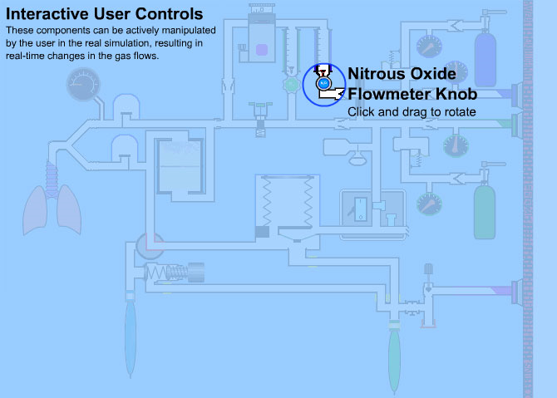

What happens to the flow of N₂O from the pipeline?

Trace along the plumbing for the path of the N₂0 gas. Where does it wind up?

It’s immediately mixed with the fresh O₂ gas described earlier, so with mechanical ventilation selected and the ventilator switch off, it flows slowly back trough the CO₂ absorber and into the scavenging system.

Is there a change in fresh O₂ flow? Why?

You may have noted that as you increased the NO₂ flow past a certain point, the O₂ flowmeter opened up along with it. The two are linked to prevent having the O₂ concentration fall below about 20%.
____ Click and drag the O2 flowmeter knob icon counterclockwise until the top of the O₂ bobbin is about midway up the tube.

____ Click on the ventilator on/off switch icon to turn on the mechanical ventilation system.

____ Wait about 30 seconds to let the N₂O molecules (BLUE) reach the lungs and bellows

____ Click and drag the N₂O flowmeter knob icon fully clockwise until there are no more N2O molecules flowing in the N2O flowmeter.

____ Click and drag the O2 flowmeter knob icon fully counterclockwise until the bobbin is near the middle of the flowmeter tube.

Does the residual N₂O get expelled from the system, or does it get rebreathed?

N₂O molecules remain in the circuit for a fairly long time after the N₂O flowmeter has been reduced to zero. Watch the system for a while, and track the path of the remaining gas.

How long do you think it would take for the N₂O to clear out completely?

This is a function of the “time constant” of the system at these settings. (The time constant would be the time it would take for the system to reach 63% of the step change - for example, the time to reach a concentration of about 31% N₂O if you were going from 0% to 50% N₂O. To clear out completely would require 3 times constants in general.)

Will this time constant be greater if the flow of fresh gas was greater?

No, the time constant will be shorter because the N₂O will be cleared faster by the higher flow of fresh gas.

Review of Question 2: changes in fresh gas flow concentration. You are anesthetizing the patient with a minimal flow of nitrous oxide (N₂O) mixed in with the fresh O₂. In preparation for emergence from anesthesia, you turn off the N₂O flow. Is your patient now inhaling gas with 0% N₂O?

Answer: No, not for while.

Explanation: Breathing circuits have a “time constant” whereby a change in the set gas composition does not immediately result in a corresponding change in the inspired gas composition. This time constant is influenced by, among other things, the magnitude of the fresh gas flow and the volume of gases in the breathing circuit.

Question 3: elimination of excess gases. What is the exit for gas during the inspiratory phase of mechanical ventilation?

____ Click “Reset” to start simulation afresh

____ Click and drag the O₂ flowmeter knob icon until the bobbin is halfway up the tube.

____ Click on the ventilator on/off switch icon to turn on the mechanical ventilation system.

What is the exit route for gas during mechanical ventilation?

Look at the tubing that connects the breathing circuit with the bellows. If the selector switch is set to mechanical ventilation, there’s only one place where excess gas can reach the scavenging system below. It’s through the valve at the bottom of the bellows. This valve is called the ventilator pressure relief valve, or VPR valve (or sometimes the “spill” valve).

How does the VPR valve behave during inhalation?

At the end of inspiration, the outer chamber of the bellows is filled with “drive gas” from the O₂ supply. The VPR valve is pressurized shut by the drive gas during inspiration, and stays shut until the drive gas is released to the room.

When does the VPR valve open during exhalation?

Watch how the VPR valve opens at or near the end of exhalation, when the bellows has completely refilled.

When does the VPR valve close during inspiration?

Watch how the VPR valve closes at the moment inspiration begins.

Why does the VPR valve need to be closed during inspiration?

Where would the bellows gases go if it were open during inspiration?

Review of Question 3: elimination of excess gases. What is the exit for gas during the inspiratory phase of mechanical ventilation?

Answer: There is none.

Explanation: The ventilator pressure relief valve is the outlet for gases during mechanical ventilation, but it only relieves gas during exhalation. It is pressurized shut by the drive gas during mechanical inspiration.

Question 4: flushing with oxygen. Why should you not flush during mechanical inspiration?

Demonstration using VAM:

____ Click “Reset” to start simulation afresh

____ Click and drag the O₂ flowmeter knob icon until the bobbin is halfway up the tube.

____ Click on the ventilator on/off switch icon to turn on the mechanical ventilation system.

What routes can the high pressure O₂ gas follow when the O₂ flush valve is pressed?

How will this depend on whether the VPR is opened, or closed?

___ Click on the airway pressure gauge icon to enlarge the pressure gauge, so you can read the pressure on the gauge. The inner part of the gauge displays pressure in terms of cm of H₂O.

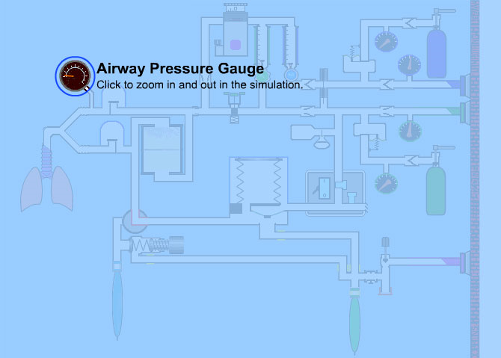

What is the maximum airway pressure during ventilation, and when is it reached?

Watch how the pressure increases steadily during inspiration, reaching a peak of about 18 cm H₂O.

____ Press the oxygen flush valve during exhalation (when the bellows is traveling up).

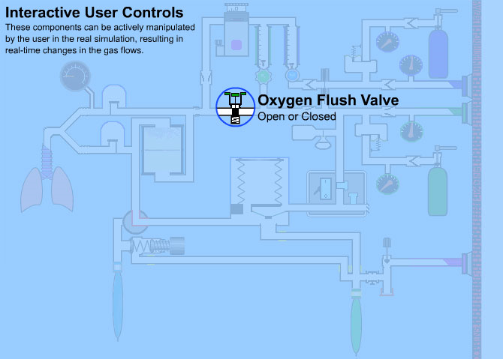

What route does the O₂ take from the high pressure line when the O₂ flush valve is pressed during exhalation?

The inspiratory valve in the airway is closed during exhalation, so it can’t go there. The route is “backwards” through the CO₂ absorber, a bit into the expanding bellows, and then, when the VPR valve opens (see question 3), on to the scavenging system.

What is the maximum airway pressure with a flush during exhalation?

Note that as you press the flush valve during exhalation, it has no effect on the (dropping) airway pressure. Why is that?

The expiration valve is unidirectional, so the flushed O2 gas can’t flow into the airway, and instead takes the route outlined above.

____ Press the oxygen flush valve during inspiration. Note the warning. Why are you being warned?

What route does the O₂ take from the high pressure line when the O₂ flush valve is pressed during inspiration?

Since the VPR is pressurized closed, the O₂ flows into the lungs along with the gases coming from the bellows.

What is the maximum airway pressure with a flush during inspiration?

As you press the flush valve during inspiration, the pressure increases rapidly (this is a high pressure line, after all). It peaks at about 40 cm of H₂O, but then quickly dissipates (does not dissipate if you keep pushing the O₂ flush).

Why does it peak at 40 cm H₂O, rather than continue to increase and create hyperinflation?

Look at the setting of the Inspiratory Pressure Limit (IPL) setting on the lower right panel.

Review of Question 4: flushing with oxygen. Why should you not flush during mechanical ventilation?

Answer: Because the O₂ flush gas will flow to the lungs and hyperinflate the lungs until the inspiratory pressure limit (if properly set) is reached, risking barotrauma.

Explanation: An O₂ flush valve delivers about 1 L/sec into the breathing circuit – a lot of gas. With the VPR valve shut during mechanical inspiration, the gas can only wind up in the lungs, raising the pressure to potentially dangerous levels. The default IPL setting on some actual machines may be set anywhere from 40 cm to 60 cm H₂O or greater. So, flush when the bellows are moving up!

Question 5: The APL valve.The adjustable pressure-limiting (APL) valve is closed after switching to mechanical ventilation for maintenance of anesthesia. Switching back to manual ventilation for emergence from anesthesia, you forget to adjust the APL valve, and squeeze the manual ventilation bag. What happens?

Demonstration using VAM:

____ Click on the APL valve icon three times until it is fully closed (spring coils are tightly coiled).

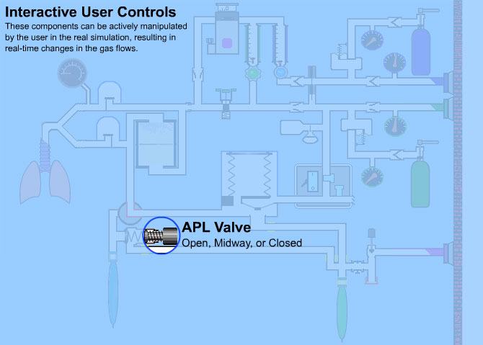

Can an open APL valve cause a “leak” during mechanical ventilation?

Note the location of the APL valve within the manual ventilation circuit. It’s located below the switch that selects for manual or mechanical breathing systems, and so is part of a second “exit route” for gases that only functions during manual ventilation. Its setting during mechanical ventilation is irrelevant, at least in this version of the anesthesia machine. (In others, it’s placed above the selector switch and creates a leak if left open during mechanical ventilation).

____ Click and drag the O₂ flowmeter knob icon counterclockwise until the O2 bobbin is fully up at the top of the tube:

____ Click on the selector knob icon to select manual ventilation. Look at the position of the inspiratory and expiratory valves in the breathing circuit.

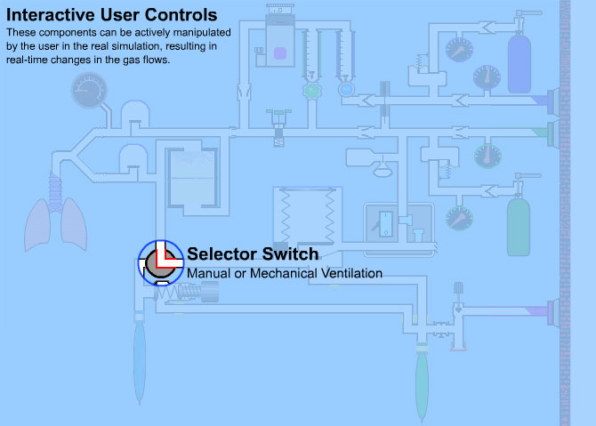

Does the airway pressure begin to increase even before you’ve squeezed the bag?

Watch what happens as the bag starts to inflate from the gases being delivered by the O₂ flowmeter input. At first, the airway pressure stays low; but then as the bag starts to swell and pressure builds, the inspiratory valve opens, allowing gas into the lungs.

____ Click on the airway pressure gauge icon to enlarge the gauge.

How high can the airway pressure get? Watch as the gauge climbs to about 40 cm H₂O and plateaus there.

____ Click on the manual ventilation bag to squeeze it.

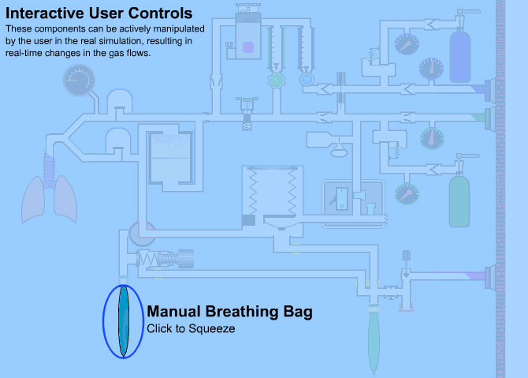

What happens to airway pressure?

Momentarily, it climbs to about 70 cm H₂O, but quickly returns to about 40 cm H₂O.

Is this because of the Inspiratory Pressure Limit setting on the ventilator (remember the setting at the lower right)?

No, the IPL setting only affects the mechanical ventilation system. With manual ventilation, it’s the compliance of the squeeze bag, which, at 40 cm H₂O, can increase a lot in volume with no change in pressure.

What happens to the lungs?

40-50 cm H₂O is enough to cause some barotrauma, stylized here with reddened tissue.

____ Click on the APL valve once to partially open it.

What happens to airway pressure now?

Pressure is released, and excess gas exits to the scavenger system. Pressure drops to about 16 cm H₂O, which is the pressure setting

____ Give the manual ventilation bag a couple of squeezes.

What happens to airway pressure now?

From the resting, APL-controlled pressure of about 16 cm H₂O, it peaks at about 24 cm H₂O during inspiration, then drops back down during exhalation. You can see the inspiratory valve, then the expiratory valve, open and close in turn during manual ventilation. This is how the system functions normally.

Review of Question 5: The APL valve. The adjustable pressure-limiting (APL) valve is closed after switching to mechanical ventilation for maintenance of anesthesia. Switching back to manual ventilation for emergence from anesthesia, you forget to adjust the APL valve, and squeeze the manual ventilation bag. What happens?

Answer: It gradually increases until it plateaus at about 40 – 50 cm H₂O. But you can squeeze to generate higher pressures up to 70 cm H₂O. A totally closed APL valve won’t relieve until pressure reaches 70 cm H₂O.

Explanation: The function of the APL valve is to limit airway pressure during manual ventilation. In the simulation, it’s set for about 16 cm H₂O. Fully closed, it will only let gas flow through it when pressure reaches about 70 cm H₂O. The breathing bag can continue expanding with minimal change in pressure once we reach 40 – 50 cm H₂O.

This completes the training tutorial on the anesthesia machine.

While you’re not yet ready for an internship in anesthesiology, you’ve learned some of the basics of operation of the traditional anesthesia machine used worldwide during general anesthesia, and some of the things that need to be monitored during its use.

This is a good time to review again the questions we’ve answered during the tutorial. Just read through the list below, and see if you can answer the questions by remembering those conditions in the simulation.

Question 1: elimination of CO₂. Are the gases exhaled by a patient “scrubbed” of CO₂ before entering the bellows during mechanical ventilation?

Question 2: changes in fresh gas flow concentration. You are anesthetizing the patient with a concentration of 30% oxygen (O₂) mixed with 70% nitrous oxide (N₂O). In preparation for emergence from anesthesia back into consciousness, you turn off the N₂O flow to set the O₂ concentration to 100%. Is your patient now breathing 100% O₂?

Question 3: elimination of excess gases. What is the exit for gas during the inspiratory phase of mechanical ventilation?

Question 4: flushing with oxygen. Why should you not flush during mechanical inspiration?

Question 5: The APL valve. The adjustable pressure-limiting (APL) valve is closed after switching to mechanical ventilation for maintenance of anesthesia. Switching back to manual ventilation for emergence from anesthesia, you forget to adjust the APL valve, and squeeze the manual ventilation bag. What happens?

