The France Florida Research Institute presents
‘French language and its regions on the big screen
from “Bienvenue Chez les Ch’tis” to “Les Neiges du Kilimandjaro” ‘

A lecture by Dr. Kevin Elstob
March 14, 2016
Room TURLINGTON 2306 - 4:05 pm-5pm

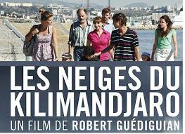

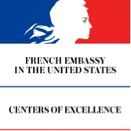
This event is free and open to all.
Sponsored by:
France-Florida Research Institute
University of Florida.

